The Ottawa Mood Scales

Help yourself, or a loved one express their feelings more easily! Next time you ask how someone feels and they just say “fine” or “okay”, use these scales to help find out how they really feel! The Ottawa Mood Scales are a series of scales designed to help children, youth (and adults!) express various moods:

- Arousal / Self-Regulation Scale: How Are You feeling?
- Mood Scale: How is Your Mood?
- Anger Scale: How Much Anger?
- Worry Scale: How Much Anxiety / Worry?
- Stress Scale: How Much Stress / Upset?

Designed for use by children, youth, caregivers, teachers and healthcare professionals. Contact us through our websites if you would like to adapt for your own use or translate into other languages. Images courtesy of www.aperfectworld.org

Michael Cheng, www.drcheng.ca, Ottawa, Ontario, Canada
How Are You Feeling?

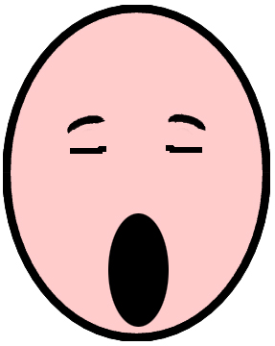 |  | 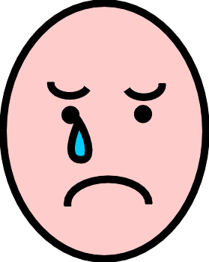
Bored  (Underwhelmed, Understimulated) | “Just Right” | Frustrated, Mad, Angry, Upset  (Overwhelmed, Overstimulated)
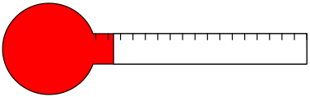 | 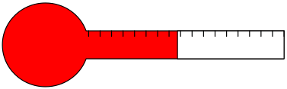 | 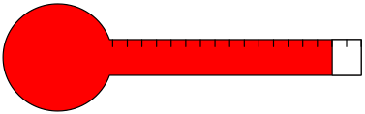

Stress/Arousal Scale: How are You Feeling?
Underwhelmed / Understimulated | “Just Right” | Overwhelmed, Overstimulated
- Not enough stimulation  - May be bored, lethargic  - Demands/expectations much less than person’s ability to cope | - Just enough stimulation  - Demands/expectations match person’s ability to cope | - Too much stimulation  - Angry, scared, or shut down (“fight, flight or freeze”)  - Demands/expectations much greater than person’s ability to cope
Solution  - ⬆ stimulation  - Soothing or modulating strategies | Solution  - Continue doing the same thing  - Modulating strategies | Solution  - ⬇ stimulation/expectations  - Soothing or modulating strategies

Mood Scale: How Is Your Mood?

 | Sad, Depressed, Down |  |  |  | In the Middle, Not Happy nor Sad |  |  |  |  | Happy, High, Awesome, Great
 |  |  |  |  |  | 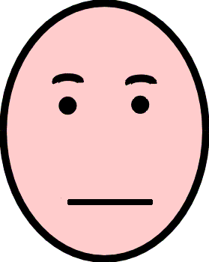
 | 0 | 1 | 2 | 3 | 4 | 5 | 6 | 7 | 8 | 9 | 10

Anger Scale: How Much Anger is There?

 | Calm, Peaceful, Relaxed |  |  |  | Irritated, Annoyed, Frustrated |  |  |  |  |  | Angry, Infuriated
 | 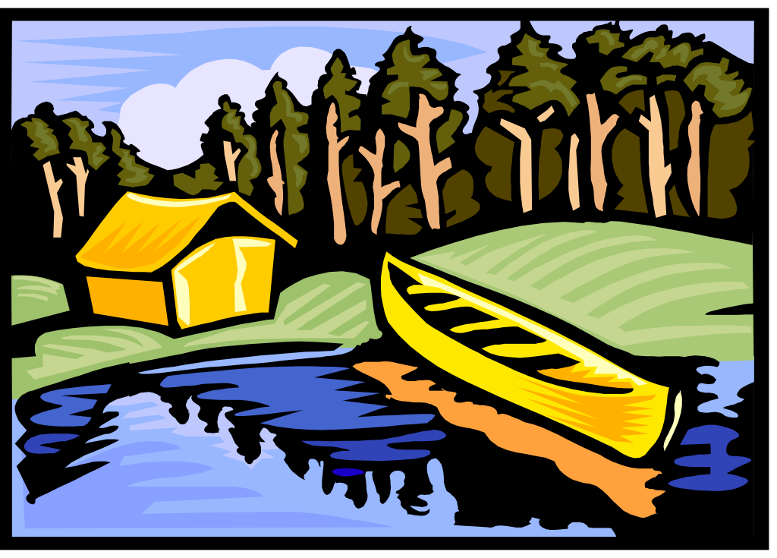
 | 0 1 2 3 4 5 6 7 8 9 10

Worry Scale: How Nervous or Worried?

Calm, Relaxed, Confident |  |  |  | Nervous, Worried, Afraid, Anxious, Scared |  |  |  |  |  | Panic, Overwhelmed, Terrified
 | 0 | 1 | 2 | 3 | 4 | 5 | 6 | 7 | 8 | 9 | 10

Stress Scale: How Much Stress / Upset?

Calm, Relaxed, Confident  No distress or stress |  |  |  | Somewhat stressed |  |  |  |  |  | Completely distressed, overwhelmed or stressed out!
 | 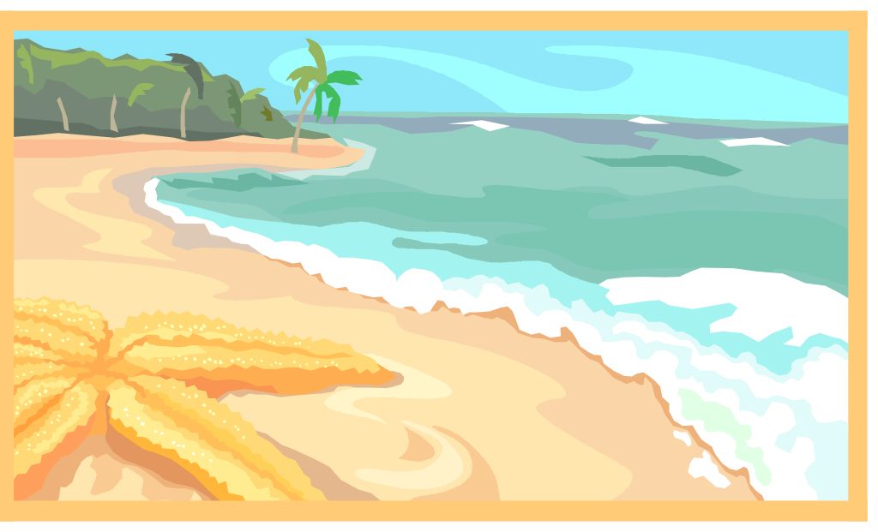
 | 0 | 1 | 2 | 3 | 4 | 5 | 6 | 7 | 8 | 9 | 10

Stress Scale: How Much Stress / Upset?

Calm, Relaxed, Confident  No distress or stress |  |  |  | Somewhat stressed |  |  |  |  |  | Completely distressed, overwhelmed or stressed out!
 | 0 |  | 1 |  | 2 |  | 3 |  | 4 |  | 5

